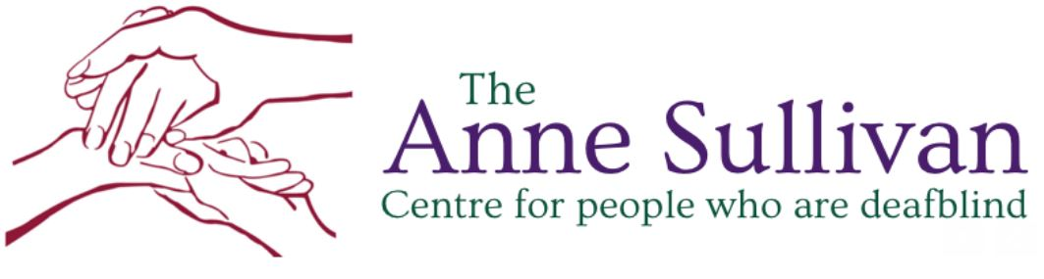

**CHILD SAFEGUARDING STATEMENT**

**May 2018**

|  |  |  |
| --- | --- | --- |
| Document Control | | |
| **Document Reference No:** |  | |
|  |  | **Date** |
| **Statement developed by**   * Catherine McDonald (Policy and Advocacy Lead) * Grace Kelly Hartnett (CEO) * Heather Colson Osborne (Designated Officer) * Deirdre Leech (Deafblind Specialist Consultant) | | May 2018 |
|  |  |  |
| **Authorised by:** Grace Kelly Hartnett (CEO) | | |

|  |  |  |
| --- | --- | --- |
| **Document review** | | |
| Date of Review | Reviewed by | Document amended? | **Next Review Date** |
| **March 2020** | Shannen Connolly (Social Care Worker) | No necessary edits | **March 2023** |
| **August 2022** | S.Sheppard | DO’s updated | **August 2023** |

**CHILD SAFEGUARDING STATEMENT**

**1. Name of service and activities provided**

The Anne Sullivan Centre (ASC) is a not for profit organisation providing support and services to individuals who are deafblind in Ireland. The ASC provides residential, day, respite and information supports to adults who are deafblind and also provides advocacy and outreach services to both adults and children. The ASC organisational structure is depicted in Figure 1 below:



Figure 1: ASC Organisational and management structure.

**2. Commitment to safeguard children from harm**

* The ASC is committed to safeguarding the children availing of our services and to providing a safe environment in which they can learn and develop.
* The ASC believes that the welfare of the children availing of our service is paramount. We are committed to child-centred practice in all our work with children.
* We are committed to upholding the rights of every child and young person, including the rights to be kept safe and protected from harm, listened to, and heard.
* Our policy and procedures to safeguard children and young people reflect national policy and legislation and are underpinned by Children First: National Guidance for the Protection and Welfare of Children 2017, the Tusla Children First - Child Safeguarding Guide 2017, and the Children First Act 2015.
* Our policy declaration applies to all paid staff, volunteers, board members and students on work placement within our organisation. All board members, staff, volunteers and students must abide by the policies, procedures and guidance encompassed by this policy declaration and our child safeguarding policy.
* We will review our child safeguarding statement and accompanying child safeguarding policies and procedures every 2 years or sooner if necessary, due to service issues or changes in legislation or national policy.
* There are Designated Officers in place to which suspicions or allegations of abuse can be reported. Please see Table 1 below.

|  |  |  |
| --- | --- | --- |
| **Designated Officer 1**  Bronwyn Kircher  [bkircher@annesullivancentre.ie](mailto:hcolsonosborne@annesullivancentre.ie) Phone: 087 637 7933 | **Designated Officer 2**  Sorcha Nallen  [snallen@annesullivancentre.ie](mailto:snallen@annesullivancentre.ie)  Phone: 087 7462472 | **Designated Officer 3**  **Karen Coleman**  [kacoleman@gmail.com](mailto:kacoleman@gmail.com)  Phone: 086 3324612 |

**Table 1: Designated Officers in the ASC to which allegations or concerns of abuse can be reported.**

**3. Risk Assessment**

In accordance with the Children First Act 2015, the ASC has carried out an assessment of any potential for harm to a child while participating in service activities. A summary of the areas covered in the risk assessment meeting can be found in Appendix 1. A written assessment setting out the areas of risk identified and the service procedures for managing those risks is summarised in Table 2 below:

|  |  |
| --- | --- |
| **Risk Identified** | **Policy/Procedure in place to manage the risk** |
| One to One teaching | ASC Child Protection Policy  ASC Charter of Rights 2016  ASC Comments, Compliments and Complaints Policy  ASC Policies and Procedures on Communicating with  children and adults who are deafblind.  ASC Speak up/Protected Disclosures Policy  ASC Recruitment and Selection Policy  ASC Positive Behaviour Support Policy  ASC Lone Working Policy  ASC Code of Behaviour |
| Outdoor activities | In addition to what has already been listed:  ASC Safety Statement  ASC Risk Management Policy |
| Outings | In addition to what has already been listed:  ASC Policies and Procedures on Missing Persons |
| Management of challenging behaviour | As above |
| Administration of first aid | In addition to what has already been listed above  ASC Staff Training and Development Policy |
| Use of information and communication  technology | In addition to what has already been listed above  ASC Email Policy  ASC Internet Policy  ASC Social Media Policy |
| Social events | As above |
| Individual records | In addition to what has already been listed above:  ASC Confidentiality Policy  ASC Record Management and Data Protection Policy |

Table 2: Risk and risk management regarding child protection

**4. Child Safeguarding Policies and Procedures**

As required by the Children First Act, 2015 and the Children First National Guidance for Protection and Welfare of Children 2017, the following safeguarding policies/procedures/measures are in place

* Designated Officers have been appointed
* Child Protection and Welfare Reporting Procedures
* Confidentiality Policy
* Policy provides information on dealing with allegations of abuse or neglect against employees
* Procedure for managing data and records
* Recruitment Policy
* Garda Vetting Policy
* Code of Behaviour
* Induction Policy (which includes procedures to inform new staff about the Child Safeguarding Statement and accompanying safeguarding policies and procedures)
* Policy on communicating with children and adults who are deafblind
* All staff asked to complete the HSE Land eLearning module – *Introduction to Children First* and relevant staff have attended Children First Child Protection Training.
* Staff have access to regular Supervision and Support in line with the ASC policy.
* Comments, Complaints & Complaints Policy
* ASC Adverse Events and Incident Management Policy
* Social Media Management Policy

**Note:** *The above is not intended as an exhaustive list.*

**5. Implementation and Review**

* We recognise that implementation is an ongoing process. Our service is committed to the implementation of this Child Safeguarding Statement and the accompanying child safeguarding policies and procedures that support our intention to keep children safe from harm while availing of our service.
* This Statement will be reviewed every 2 years or as soon as practicable after there has been a material change in any matter to which the statement refers.
* This statement is displayed in the service. It has been provided to all staff, volunteers and any other persons involved with the service. It is readily accessible to parents and guardians on request. A copy of this Statement will be made available to Tusla or HIQA if requested.

**Signed:** _______________________ **Date:** _________________

**Service Provider’s name and contact details:**

**For further information on this Statement, contact the Designated Officers. Contact details are on p.4 of this statement.**

**Appendix 1: Child Protection Risk Assessment**

**Date of risk assessment: 23-04-18**

**Present:** Deirdre Leech (Deafblind Specialist Consultant), Heather Colson Osborne (Designated Officer, Catherine McDonald (Policy & Advocacy Lead, Grace Kelly Hartnett (CEO)

At this risk assessment meeting, those present listed the activities that the organisation engages in with children, identified the risk of harm in respect of the activities outlined above and identified the procedures in place to address the risks of the harm identified.

|  |  |  |
| --- | --- | --- |
| **Activity** | **Risk**  **identified** | **Comments** |
| Classroom teaching | None | Teacher is always present |
| One to one teaching | Yes | Identified list of policies and procedures to address the risk |
| Outdoor activities | Yes | Identified list of policies and procedures to to to address the risk |
| Outings | Yes | Identified list of policies and procedures to to to address the risk |
| Trips involving overnight stay | No | Not currently offered to children by ASC |
| Use of toilet/intimate care | No | Outreach workers do not provide intimate care  supports |
| Management of challenging  behaviour | Yes | Identified list of policies and procedures to to to address the risk |
| Administration of First Aid | Yes | Identified list of policies and procedures to to to address the risk |
| Administration of medication | No | Outreach workers do not administer  medication |
| Use of ICT | Yes | Identified list of policies and procedures to to to address the risk |
| Use of video/photography | Yes | Identified list of policies and procedures to to to address the risk |
| Social events | Yes | Identified list of policies and procedures to to to address the risk |